DWBI Assignment II

Amit Shiva Kumar (NUID 001820354)

Q1. Export the HumanResources.Employee table from AdventureWorks

We develop a SSIS package, to achieve this we create a data flow task add the Source Assistant as SQL server, and then connect a destination flat file. Descriptive names have been used for each of these.

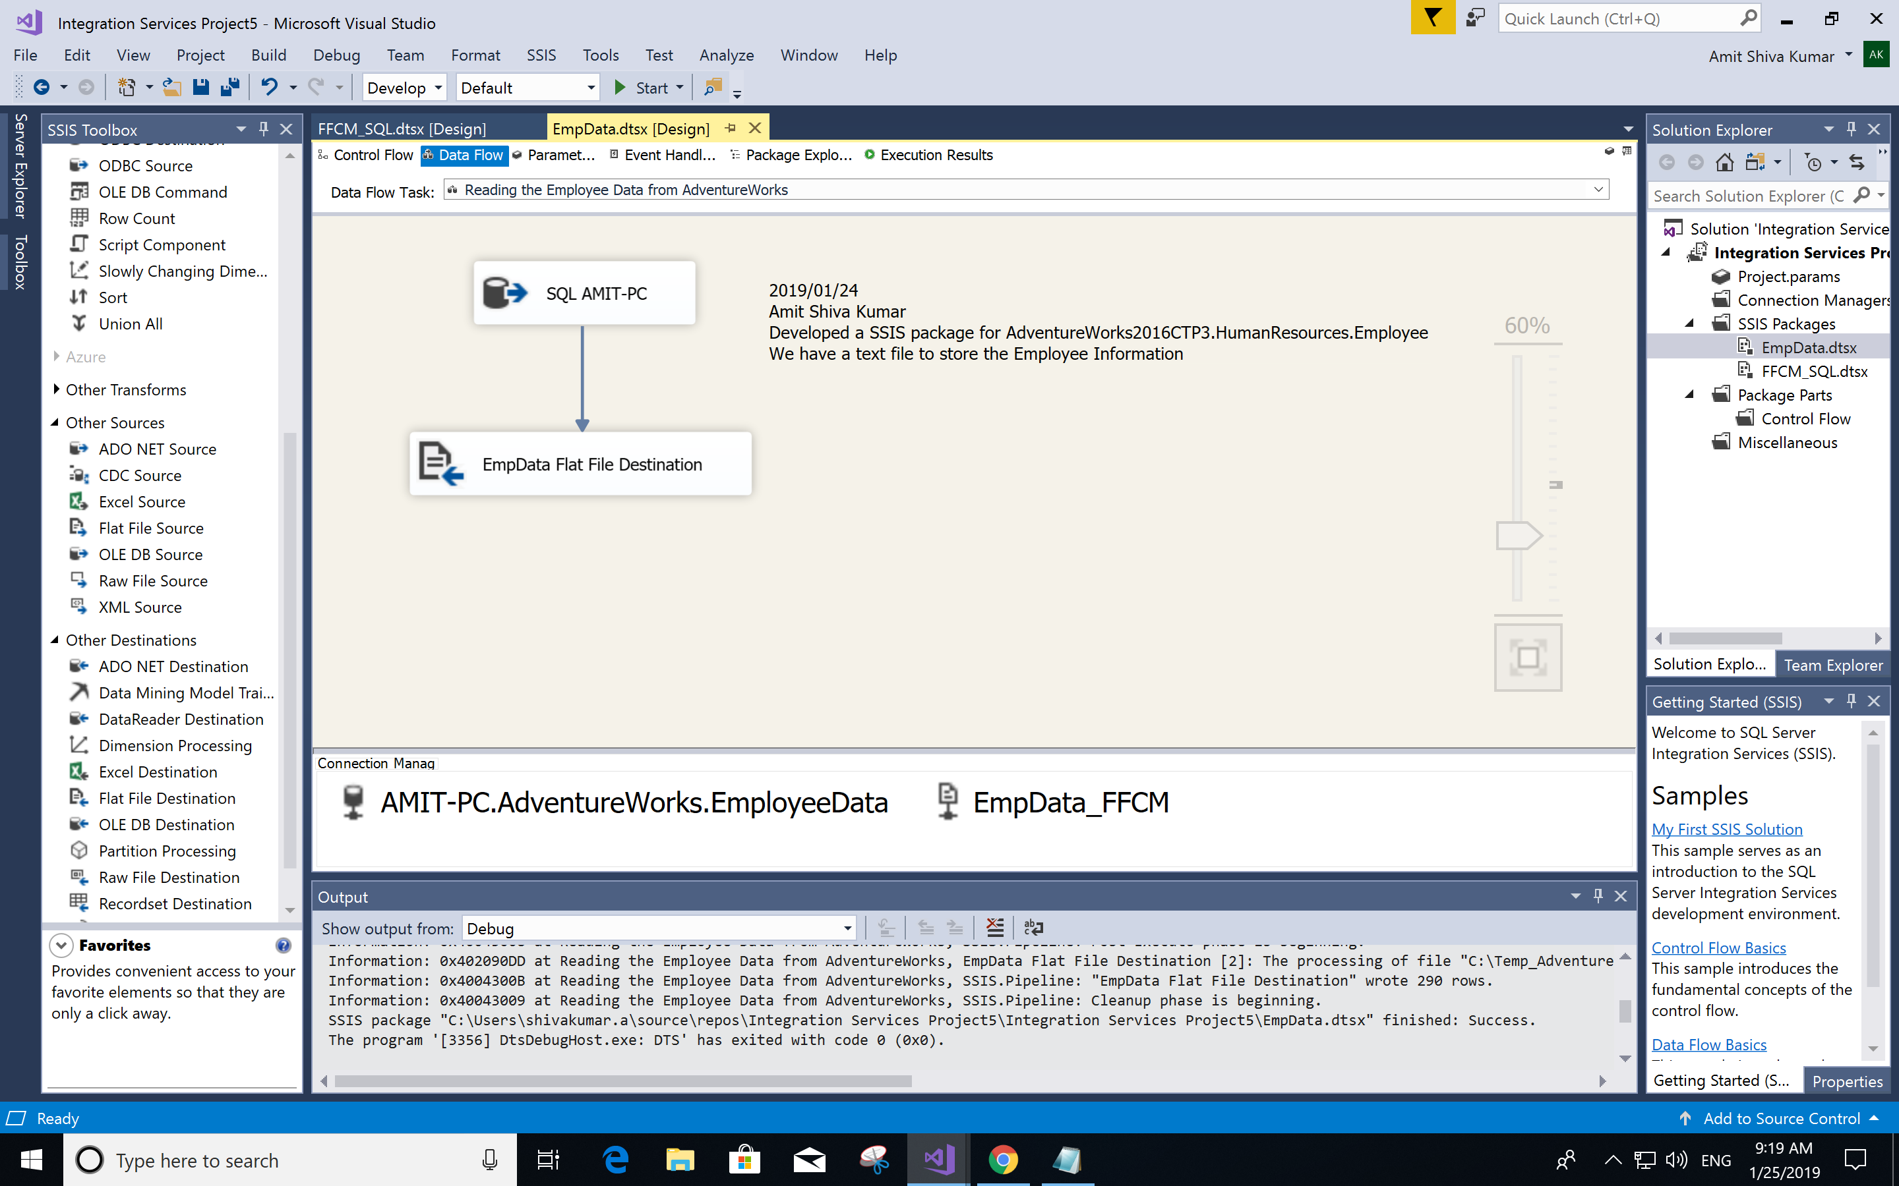

Once processed as shown, it will create a Flat File with the required data in delimited format in the destination.txt file

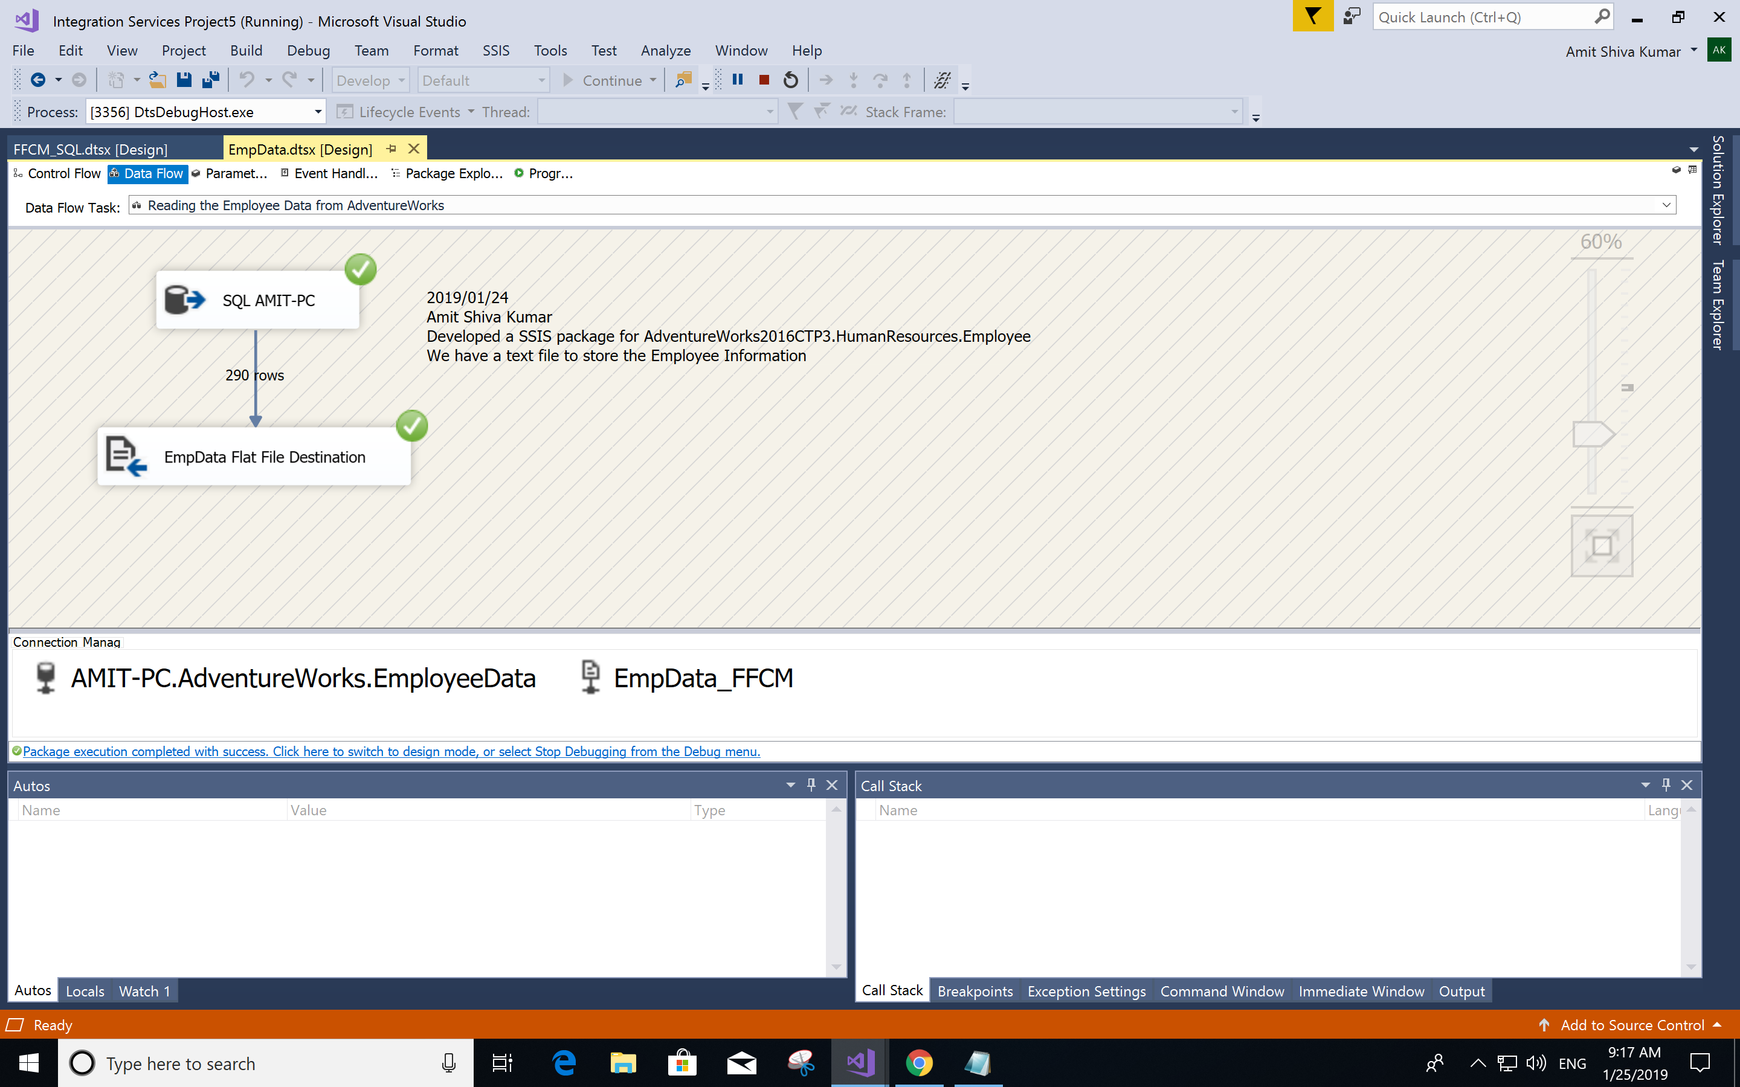

Execution:

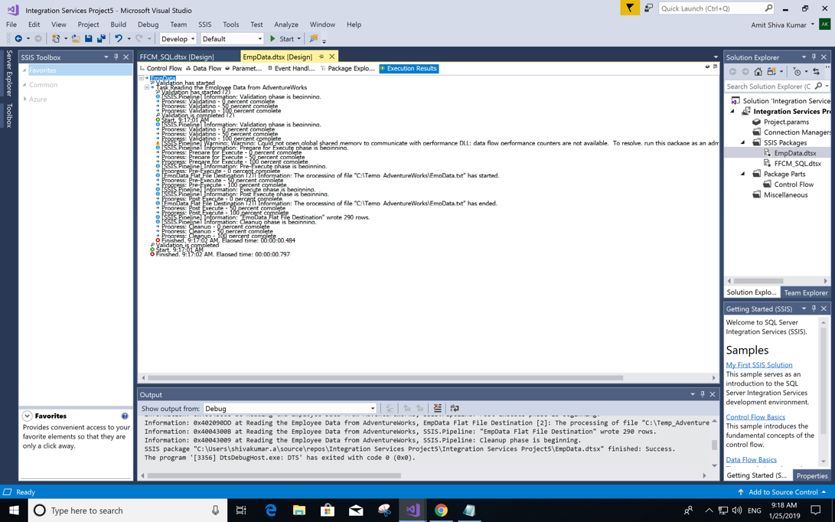

Q2. Create a script for Staging Table for importing the Employee Data

We create a staging table [HumanResources].[Employee_Info_Staging] in [AdventureWorks2016CTP3] database for importing the Employee Data from the flat file created in step 1. We aim to make the staging table less restrictive compared to the HumanResources.Employee table.

Below is the SQL Query and the resulting staging table.

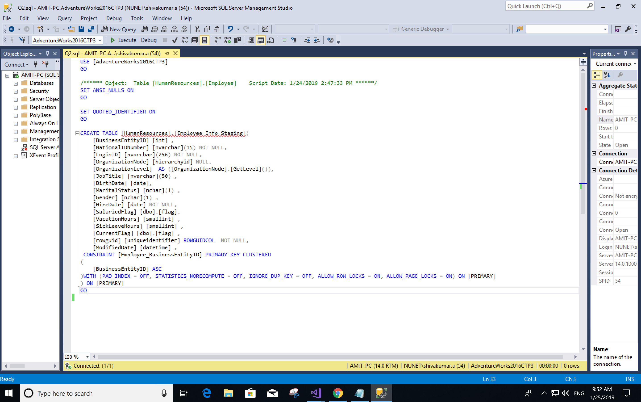

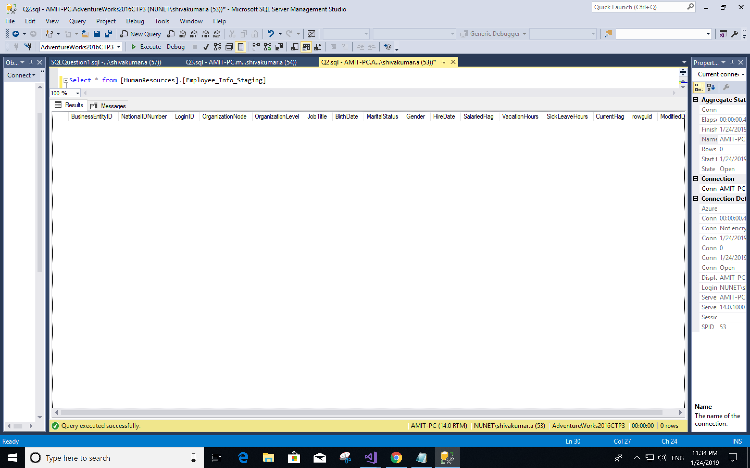

Q3. Create a SSIS Package to Load the Data

We create a package with the Source as Flat file and destination as OLE DB as shown below.

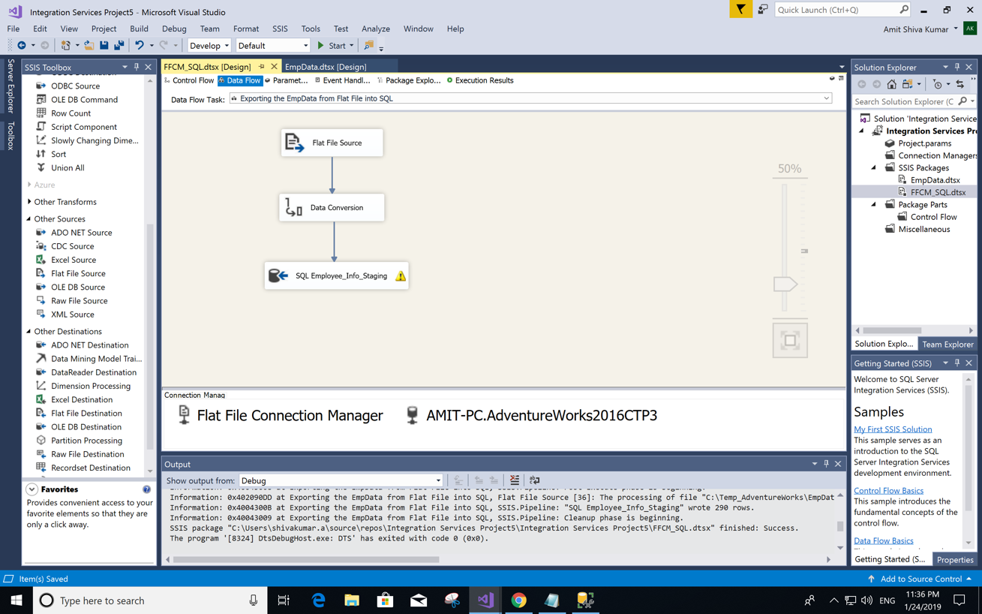

We use the Data Conversion to avoid the Unicode and Non Unicode Conversion Error. Successful execution of this package is shown below.

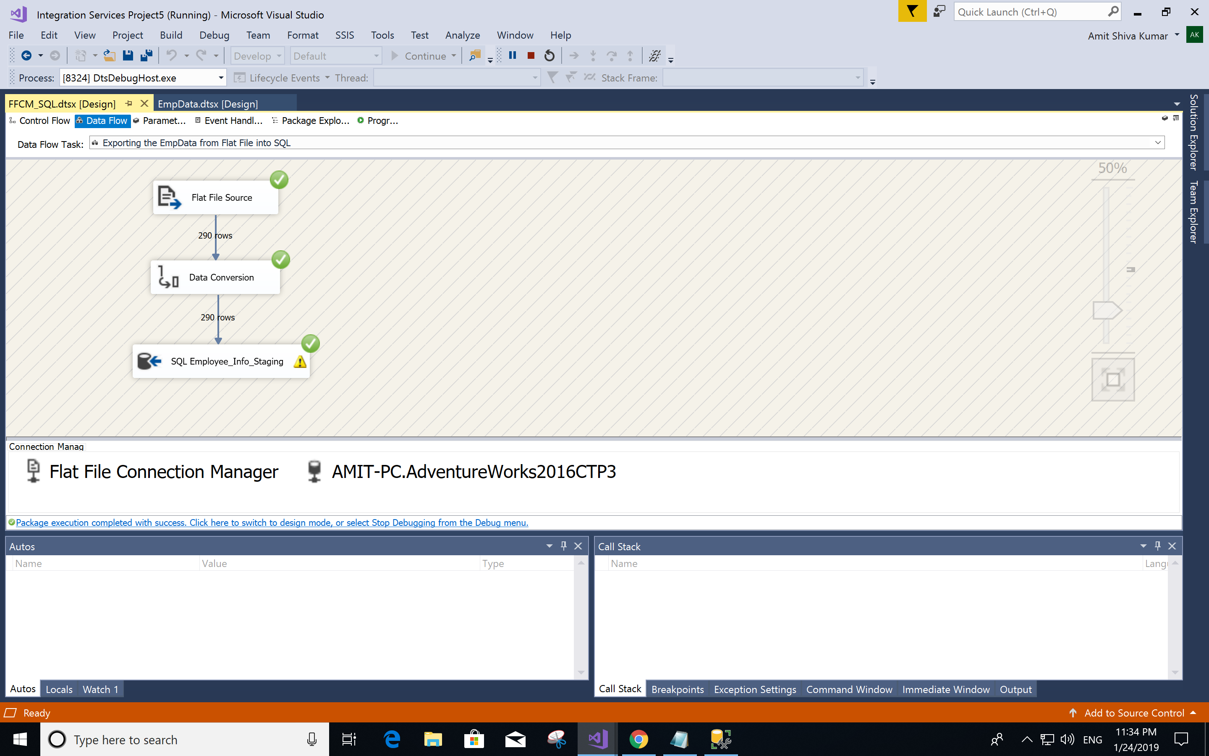

After we execute the FFCM_SQL.dtsx package we would observe that the [HumanResources].[Employee_Info_Staging] table is populated with the required information.

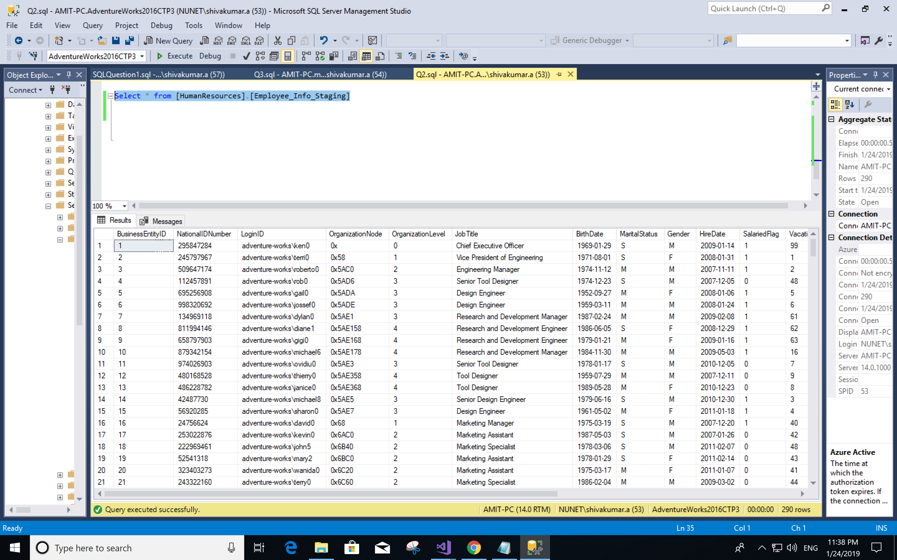

Step by step data flow:

EmpData

Flat File

[HumanResources].[Employee_Info_Staging]

Staging Table (Destination)

[HumanResources].[Employee]

Source Table

We observe that all 290 rows have been inserted into the staging table [HumanResources].[Employee_Info_Staging] from the source table [HumanResources].[Employee] using the flat file EmpData.txt

GIT repository link: <https://github.com/amit9511/Exporting-and-Importing-Data-using-SSIS-Package.git>